Task 3 Website Traffic & Event Analysis
Objective
The objective of this project is to analyze event and traffic-related data to understand user activity, geographic patterns, popular content, and event trends for Alfido Tech.
Dataset
Source: Kaggle – Website Traffic Analysis
Columns: event, date, country, city, artist, album, track, isrc, linkid
Data Preparation
The dataset was checked for missing values and duplicate records. Duplicate records were removed and the date column was converted into a proper date format. Additional features such as year, month, and day were created for time-based analysis.
Key Metrics
Analysis Performed
- Daily and monthly event trends
- Event type distribution
- Top countries by activity
- Top cities by activity
- Top artists
- Top tracks
- Artist-level content and geographic analysis
- Event distribution across countries
Key Insights
The analysis identifies the most active locations, frequently occurring event types, popular artists and tracks, and changes in activity over time. These insights can help understand audience behavior and content engagement patterns.
Recommendations
- Focus on high-activity locations with targeted campaigns and localized content.
- Promote popular artists and tracks to increase user engagement.
- Study high-performing event types and optimize experiences around them.
- Improve content discovery using popular artists, albums, and tracks.
- Monitor activity trends over time to plan campaigns and content strategies.
Important Data Limitation
The available dataset does not contain fields for sessions, session duration, bounce rate, users, or conversion rate. Therefore, these website metrics cannot be calculated reliably from this dataset.
Dataset
Source: Kaggle – Website Traffic Analysis
Notebbook Link: https://www.kaggle.com/code/chanchalkarnawat/task3
Screenshots:
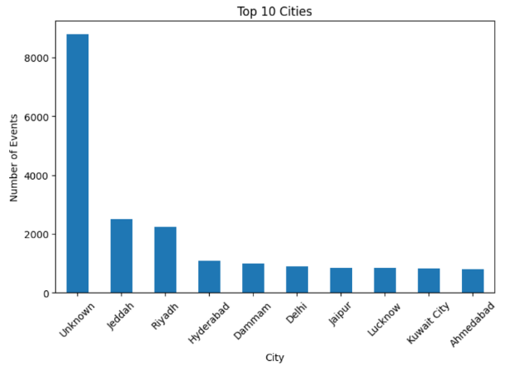
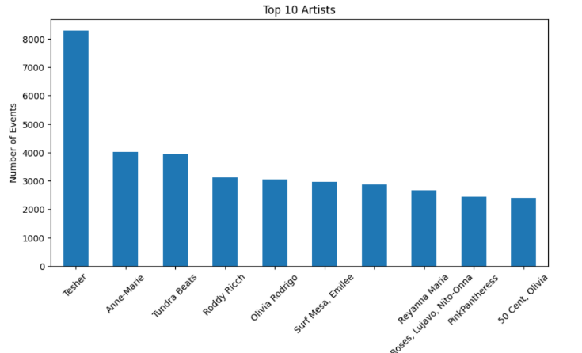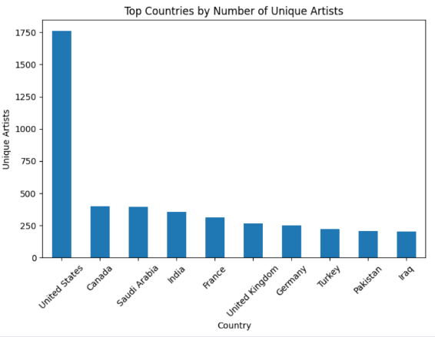
Conclusion
The analysis provides a clear view of event activity, geographic distribution, and content popularity. These findings can support targeted marketing, content promotion, and audience engagement strategies for Alfido Tech.

